Patient Monitoring System Device

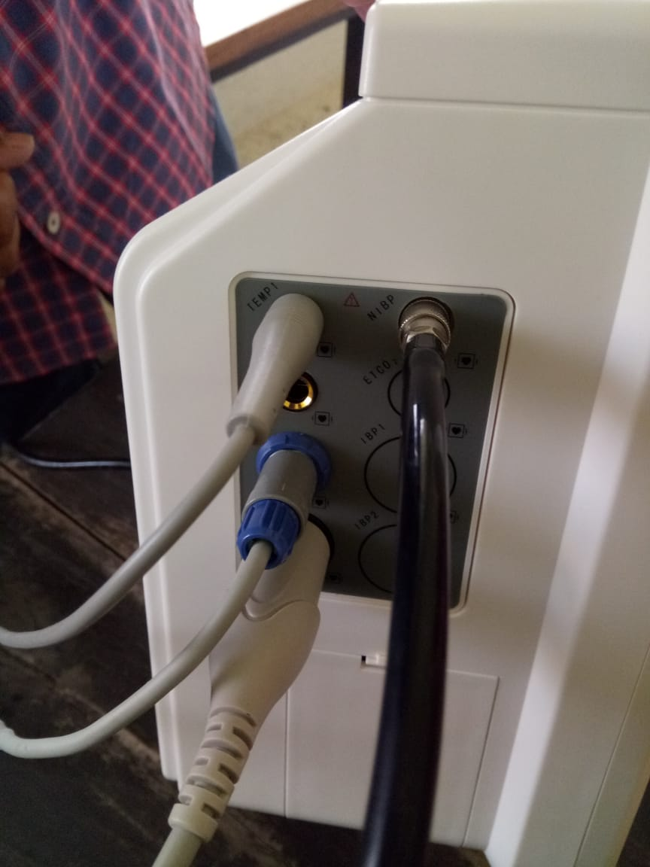

Figure 4.1: Different ports of PMS

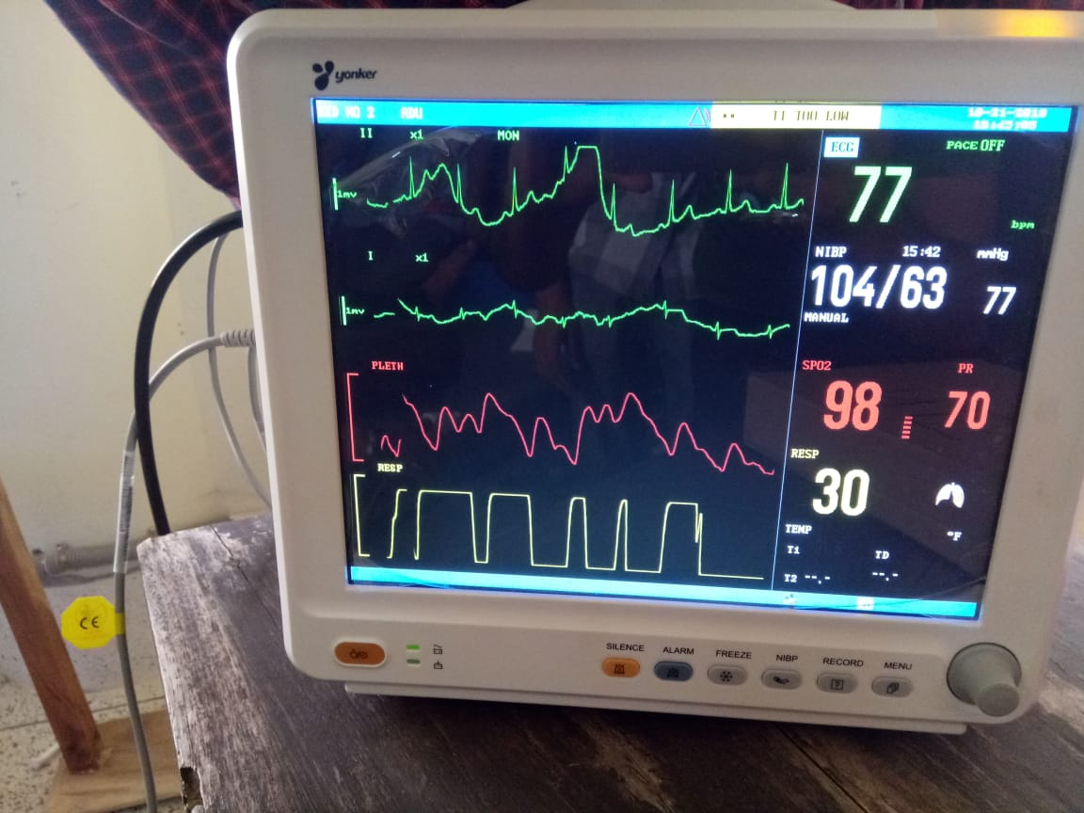

Figure 4.2: Observation of different physiologic signal in the multi- parameter PMS device

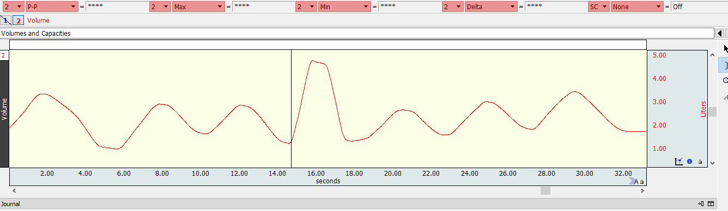Figure 4.3 : Data curve of respiration rate for analysis